Project Design Phase-II Technology Stack (Architecture & Stack)

|  |  |
| --- | --- |
| Team ID | PNT2022TMID47932 |
| Project Name | Project – Smart Solution for Railways |

Technical Architecture:

The Deliverable shall include the architectural diagram as below and the information as per the table1 & table 2

Example: Order processing during pandemics for offline mode Reference:

Guidelines:

1. Include all the processes (As an application logic / Technology Block)
2. Provide infrastructural demarcation (Local / Cloud)
3. Indicate external interfaces (third party API’s etc.)
4. Indicate Data Storage components / services
5. Indicate interface to machine learning models (if applicable)

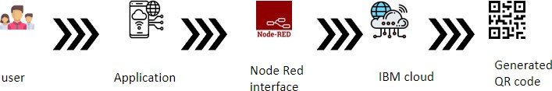

Table-1 : Components & Technologies:

|  |  |  |  |
| --- | --- | --- | --- |
| **S.No** | **Component** | **Description** | **Technology** |
| 1. | User Interface | Web UI, Mobile App. | Python, IBM cloud |

|  |  |  |  |
| --- | --- | --- | --- |
| 2. | Application Logic-1 | The Logic for book ticket in our project is very simple, because | Java / Python |
| 3. | Cloud Database | Database Service on Cloud | IBM Cloud. |
| 4. | File Storage | In storing files the user must give a correct information of them. | IBM Block Storage. |
| 5. | External API-1 | We are using live location API for tracking. | Railways Location API. |
| 6. | External API-2 | And also using API to check ticket availability, and Adhar API. | Ticket availability API, Adhar API |

Table-2: Application Characteristics:

|  |  |  |  |
| --- | --- | --- | --- |
| **S.No** | **Characteristics** | **Description** | **Technology** |
| 1. | Open-Source Frameworks | MIT app inventor, NODE RED. | Technology of Opensource framework |
| 2. | Security Implementations | Access controls implemented, use of firewalls | Encryptions. |
| 3. | Scalable Architecture | 3 – tier, Micro-services. | API |
| 4. | Availability | Use of load balancers, distributed servers. | Cloud, node red. |

References:

<https://c4model.com/>

<https://developer.ibm.com/patterns/online-order-processing-system-during-pandemic/> <https://www.ibm.com/cloud/architecture>

<https://medium.com/the-internal-startup/how-to-draw-useful-technical-architecture-diagrams-2d20c9fda90d>